How to use Zoom meeting
Step 1: Upon registration, each student will receive an email with a meeting invitation form zoom that looks like the image below.
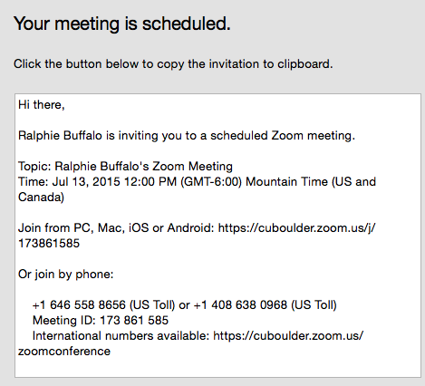

Step 2: Each student will then sign in with the link and enter meeting ID no. (to be provided) at least 5 minutes before each class begins.
After launching Zoom, click Join a Meeting to join a meeting without signing in. If you want to log in and start or schedule your own meeting, click Sign In. See image below
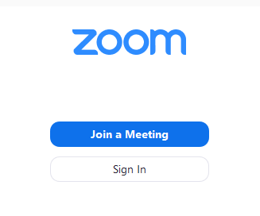
After signing in, you will see the Home tab, where they can click these options:

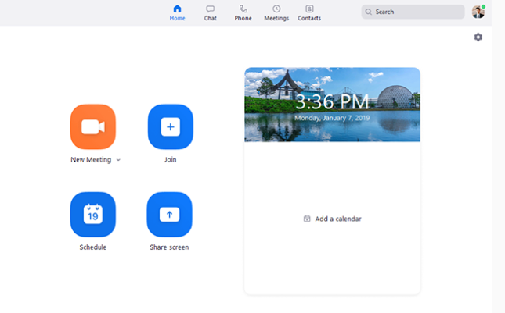
Step 3: Each Student will be linked directly to the instructor who will begin the lesson.
Note- The student will see the course on the screen while the instructor begins the discussion. A Online Systems Administration will be on sight to ensure the software is properly managed.

About Zoom Meeting Software
Zoom unifies cloud video conferencing, simple online meetings, and group messaging into one easy-to-use platform
To sign in, use your Zoom, Google, or Facebook account. You can also log in using SSO. If you don't have an account, click Sign Up Free. If you have a Zoom account but cannot remember your password, click Forgot.
More information can be found at

https://oit.colorado.edu/tutorial/zoom-host-meeting-and-invite-participants

https://support.zoom.us/hc/en-us/articles/201362033-Getting-Started-on-Windows-and-Mac

What about the final exam?
On the day of the final exam, each student will sign in to the website at https://fbbi.talentlms.com/dashboard and the instructor will enter a secure password after authentication that allows the student to do the timed final exam and submit their answers online.

